**Principles of Communications**

Baseband QAM Modem

**Aim of the Project**

* 1. Understand the basic concepts of modulation and detection, that is,

Digital modulation: BPSK/QPSK，and Maximum likelihood detection

**Requirement of the Project**

* 1. This project requires **two students** to work as a team. In case a team cannot be formed, **one student** working alone is also acceptable.
  2. You must do the experiment with USRP and be tested by TA.

**Contents of the Project**

**Summary**

In this Lab, a baseband digital modem that can use binary phase-shift keying (BPSK) or quadrature phase-shift keying (QPSK) modulation is built. The main concepts in this lab include constellation mapping, oversampling, maximum-likelihood detection, and probability of error calculation. The system considered in this lab is illustrated in Figure 1.

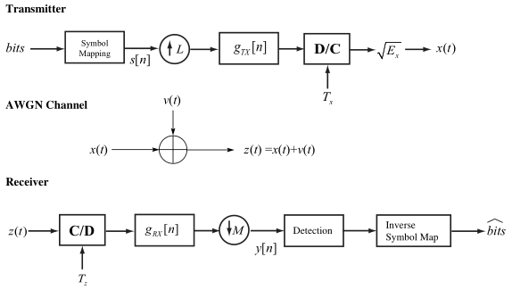

Figure 1: The system under consideration in this lab. The transmitter uses digital pulse-shaping and upsampling to create the transmit waveform. The baseband signal encounters additive white Gaussian noise during transmission. The receiver uses digital pulse-shaping and downsampling, followed by detection, to find a good guess of the transmitted symbols.

This modem transmits symbols and applies a detection algorithm assuming only an additive white Gaussian noise (AWGN) channel. The transmitter maps bits to elements of a symbol constellation. The sequence of symbols is upsampled then filtered in discrete-time by a transmit pulse shape. The filtered sequence is then passed to the discrete-to-continuous converter. The receiver samples the received signal and filters it with the receiver pulse shaping filter. The filtered symbols are passed to a detection block which determines the most likely transmitted symbol for that observation. The detected symbols are passed to an inverse symbol mapping block to produce a good guess of the transmitted bits. After verifying the functionality of this module using a simulator, you will implement it in lab using RF Hardware to see how it works over a real wireless link. The goal of this Lab is to introduce the basic concepts of modulation and detection. You will be required to plot the BER curves for QPSK and BPSK, and answer the questions in Section 2, as a part of the pre-lab requirement. There is no lab report required for this lab.

* + - 1. Background

This section provides some review of the concepts of digital modulation and maximum likelihood detection. The emphasis is on BPSK and QPSK modulation, with maximum likelihood detection assuming AWGN.

**1.1 Modulation**

Digital modulation consists of mapping a sequence of bits to a (finite) set of analog waveforms which are suitable for transmission over a particular channel. There are many different kinds modulation. This and subsequent labs focus on what is known as complex pulse amplitude modulation. With this modulation technique, symbols are modulated onto pulse-shapes.

The source for digital modulation is a sequence of bits {b[n]}. The bit sequence is passed to the physical layer of a radio by higher layers.

The sequence of bits is processed by the symbol mapping block to produce a sequence of symbols {s[n]}. Essentially, each value s[n] is a complex number that comes from a finite set of symbols called the constellation and written as



The entries of the constellation are different (possibly complex) values. The size of the constellation, or cardinality, is denoted |C| = M where M is the number of symbols in the constellation. For practical implementation  where b is the number of bits per symbol so that a group of b input bits can be mapped to one symbol.

This lab considers two of the most common modulations found in commercial wireless systems.

• Binary Phase Shift Keying (BPSK) has

C = {+1,−1}.

This is arguably the simplest constellation in use. The bit labeling is provided in Table 1. BPSK is a real constellation since it does not contain an imaginary component.

• Quadrature phase shift keying (QPSK) is a complex generalization of BPSK with

C = {1 + j, −1 + j, −1 − j, 1 − j}.

Essentially QPSK uses BPSK for the real and BPSK for the imaginary component. QPSK is also known as 4-QAM. The bit labeling is provided in Table 1.

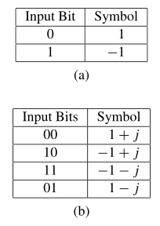

Table 1: Symbol Constellation Mappings for (a) BPSK and (b) QPSK

For implementation and analysis, it is convenient to normalize the constellation to have unit energy. This means scaling the constellation such that 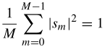.

The normalized QPSK constellation is illustrated in Figure 2.

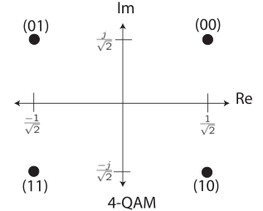

Figure 2: QPSK or 4-QAM constellation with generally accepted bit to symbol mappings based on Gray labeling.

The symbols are pulse-shaped and scaled by  to produce the complex baseband signal

 (1)

The scaling factor Ex is used to model the effect of adding energy or power to x(t). The scaling factor will be added typically in the RF by controlling the gain of the transmit power amplifier. The pulse-shape is given by the function . To preserve energy, the pulse-shaping function is assumed to be normalized such that . The symbol period is given by T. The symbol rate is 1/T.

We refer to x(t) as a complex pulse amplitude signal because complex symbols modulate a succession of pulses given by the function . Effectively, symbol s[n] rides the pulse . The symbol rate corresponding to x(t) in Eq.(1) is 1/T. The units are symbols per second. Typically in wireless systems this is measured in kilo-symbols per second or mega-symbols per second. Be careful to note that 1/T is not necessarily the bandwidth of x(t), which depends on . The bit rate is b/T (where recall there are 2b symbols in the constellation) and is measured in bits per second. The bit rate is a measure of the number of bits per second the baseband waveform x(t) carries.

Complex baseband signals are used for notational convenience. The signal x(t) is complex because the resulting wireless signal is upconverted to “ride” on a carrier frequency. After upconversion, the resulting passband signal will be . Up-conversion is performed in the analog hardware. The signal  will be launched from the transmit antennas into the propagation environment.

**1.2 Detection at the Receiver**

When a signal propagates through the wireless channel, it will be affected by noise and other types of channel distortion. They type of distortion impacts the architecture of the receiver and the design of the signal processing algorithms. In this lab, it is assumed that the transmitted signal is only impaired by AWGN. The AWGN communication channel is a good model for the impairments due to thermal noise present in any wireless communication system. Mathematically z(t) = x(t) + v(t), where x(t) is the complex baseband signal, v(t) is the AWGN, and z(t) is the observation. The assumption that v(t) is AWGN means the noise is an independent and identically distributed (i.i.d.) complex Gaussian random variable. In the presence of thermal noise, the total variance is , where k is Boltzman’s constant  and the effective noise temperature of the device is Te in Kelvins. The effective noise temperature is a function of the ambient temperature, the type of antennas, as well as the material properties of the analog front end. Under the assumed transmitted structure, the optimum receiver structure involves matched filtering, sampling at the symbol rate, and detection. The structure that will be implemented in this lab is illustrated in Figure 1. The received signal z(t), which is assumed to be bandlimited, is sampled with a sampling rate of 1/Tz . The sampling rate should be such that Nyquist is satisfied. In this lab we assume that Tz = T/M where M is the integer oversampling factor. The received signal is filtered by  where is the matched filter. After the digital filtering, the signal is downsampled by M to produce the symbol-rate sampled signal given by y[n]. The digital filtering is performed such that y[n] is the equivalent to  sampled at nT.

Under assumptions about the transmit and receive pulse-shapes, described in more detail in previous Lab, a model for the received signal is

, (2)

where v[n] is i.i.d. complex Gaussian noise with  where for complex thermal AWGN. A symbol detector is an algorithm that given the observation y[n] produces the best  according to some criterion. In this lab we consider the maximum likelihood (ML) criterion which solves

 (3)

where fy|s (·) is the conditional distribution of y[n] given s[n] and is known as the likelihood function. For additive white Gaussian noise, the conditional probability has a simple form. This allows the detection problem in Eq. (3) to be simplified to

 (4)

Essentially the algorithm works as follows. Given an observation y[n], it determines the transmitted symbol s ∈ C, scaled by  , that is closest to y[n] in terms of the euclidean distance in the error term . The algorithm in Eq. (4) can be simplified by exploiting structure and symmetry in the constellation.

*Note: If x is a complex symbol, then  , where xreal and ximag are the real and imaginary parts of x respectively.*

**Answer the following questions about PSK modulation:**

1. PSK is a constant envelope modulation scheme. This means that all symbols have equal energy after modulation. What is the energy of the BPSK and QPSK modulated symbols shown in Tables 1(a) and 1(b) respectively?

2. In modulate.vi, what should be the default value for the Symbol Energy of the modulated sequence?

3. Consider a uniformly distributed random bit stream {bn } (i.e., Prob{bn = 1} = Prob{bn = 0}). Suppose {bn } is BPSK modulated such that each symbol has energy Es . In an AWGN channel, what is the average probability of bit error as a function of SNR when using ML estimation? You may assume that noise is a real-valued Gaussian random variable with variance .

*HINT: you may leave the answer in terms of the Q-function, which is derived from the  distribution.*

**3 Lab Experiment**

In this lab you will run the implementation of modulate.vi and decode.vi over a real wireless link. Figure 2 describes the hierarchy of files you will be using in lab. The files top tx.vi and top rx.vi are the top level of the transmitter and receiver respectively. This level connects the digital communications blocks of the transmitter and receiver (in transmitter.vi and receiver.vi) with the VIs needed to control the NI RF hardware.

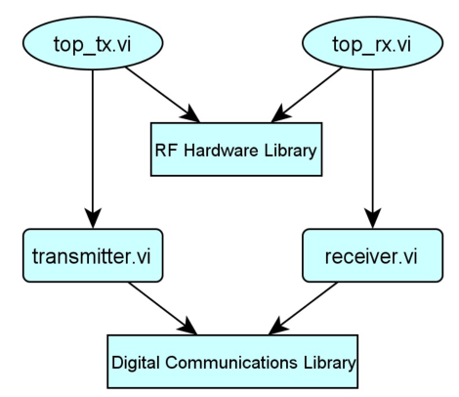

Figure 2: Hierarchy of code dramework used in lab.

**Communication Over a Wireless Link**

Before you begin testing the code over a real wireless link, set the following baseband parameters on the front panel of top tx.vi and top rx.vi:

• Packet length = 100 bits

• Modulation type = QPSK

Leave all other modulation parameters set to their default value. The following RF parameters have already been set up in the HW parameters tab of top tx.vi and top rx.vi for you:

• Carrier frequency

• TX Gain

• RX Gain

• Trigger Level

• Capture Time

The wireless digital communication system used in lab generates a small burst of data, transmits it over a wireless link, and decodes the received signal.

To run the system:

1. Start the top level of your transmitter (i.e., run top tx.vi).

2. Wait until the Transmitting indicator is lit.

3. Start the top level of your receiver (i.e., run top rx.vi).

Open the front panel of top rx.vi to see the constellation of the received signal. Note that a queue has been used to pass the key bit sequence to the receiver for error detection. Also notice, on the front panel of top tx.vi there is a control for the channel model parameters used by transmitter.vi. These parameters are used to apply a desired channel model to the transmitted signal.

The real wireless channel will convolve with this artificially imposed channel model to create a kind of equivalent channel. Answer the following questions about the digital communication system in lab:

1. What is the name of the queue used to pass the generated bit sequence from top tx.vi to top rx.vi(i.e.,the bit sequence needed to perform error detection)?

2. Describe what happens to the received constellation as you increase noise power in the top level of the transmitter, (i.e., top tx.vi).

3. Based on your observation of the received signal constellation, explain which modulation scheme (BPSK or QPSK) performs better (on average) in noisy channels, and why. Assume that both schemes are using the same average symbol energy.